# Lab # 13

## Objective: Assemble a full wave bridge rectifier circuit and observe input and output waveforms. Equipment:

* + Transformer AC center tapped (Triad F-25X or equivalent) with fuse line cord
  + Silicon diode (1N4001or equivalent)
  + Resistor ½+W (1k)
  + VOM (Analog & Digital Multimeter)
  + Oscilloscope

## Theory

**Full Wave Bridge Rectifier**

A **full-wave bridge rectifier** uses four diodes to convert the entire AC input signal into a unidirectional DC output. Unlike the center-tapped full-wave rectifier, the bridge rectifier does not require a center-tapped transformer but achieves similar results using four diodes arranged in a bridge configuration.

## Operation

During the positive half of the input AC cycle, diodes D2 and D3 are forward biased, allowing current to pass through the load resistor RL, while diodes D1 and D4 are reverse biased and block current. During the negative half-cycle, diodes D1 and D4 become forward-biased, allowing current to pass through RL in the same direction, while diodes D2 and D3 are reverse-biased.

This results in a full-wave rectified output, with current flowing through the load in the same direction during both half cycles. The ripple frequency in a full-wave bridge rectifier is twice the input frequency, resulting in smoother DC output.

## Procedure

* + Assemble the circuit as shown in Fig. using the four diodes and the transformer.
  + Connect the primary side of the transformer to the AC mains and the secondary side to the rectifier input (diodes and resistor).
  + Using a multimeter, measure the RMS voltage across the secondary winding of the transformer and record the value in Table.
  + Using an oscilloscope, measure and record the peak input voltage (before rectification) and note it in the Table.
  + Using the oscilloscope again, measure the peak output voltage (after rectification) and record it in Table.
  + Measure and record the DC load voltage across the 1kΩ resistor using the multimeter set to DC voltage mode.

## Circuit Diagram

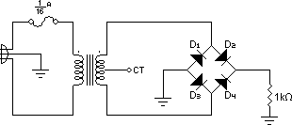

Full Wave Bridge Rectifier

## Observation Table

|  |  |  |  |
| --- | --- | --- | --- |
| **Parameters** | **Formula** | **Calculated** | **Measured** |
| **RMS secondary voltage** |  |  |  |
| **Peak input voltage** |  |  |  |
| **Peak output voltage** |  |  |  |
| **DC output voltage** |  |  |  |

**Plot the input wave and output wave:**

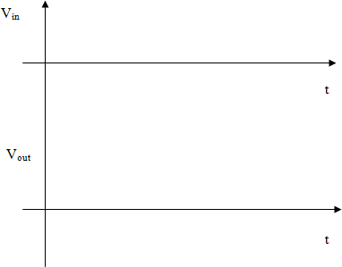

Plot the input and output waves for Full Wave Bridge Rectifier Circuit

## Result:

The full-wave bridge rectifier circuit successfully converted both the positive and negative halves of the AC input signal into a unidirectional DC output. The input waveform, as observed on the oscilloscope, is sinusoidal, while the output waveform is fully rectified with both half-cycles producing current in the same direction. The measured DC output voltage is consistent with the theoretical expectations, demonstrating efficient rectification.

## Conclusion:

The full-wave bridge rectifier provides efficient conversion of AC to DC by using four diodes to rectify both halves of the AC input signal. The ripple frequency is twice the input frequency, resulting in smoother DC output compared to a half-wave rectifier. The bridge configuration also has the advantage of requiring diodes with a lower PIV rating than a center-tapped full-wave rectifier. This experiment demonstrates the functionality and advantages of the full-wave bridge rectifier circuit.

## Safety Precautions:

* + Ensure proper insulation of the transformer to avoid electrical shock.
  + Handle the AC mains connection carefully.
  + Verify correct polarity when connecting the diodes to prevent damage.

## Post Lab:

1. What is the main difference between a full-wave center-tapped rectifier and a full-wave bridge rectifier?
2. What happens to the output waveform if the input frequency is doubled?
3. How does the ripple frequency compare to the input frequency in a full-wave bridge rectifier